Problem 1

The square footage of several thousand apartments in a new development is advertised to be 1250 square feet, on average. A tenant group thinks that the apartments are smaller than advertised. They hire an engineer to measure a sample of apartments to test their suspicions. Let µ represent the “true” mean area (in square feet) of these apartments. What are the appropriate null and alternative hypotheses?

Answer

H0 : µ = 1250 vs. Ha : µ < 1250

Problem 2

95% of the values are in two standard population differences for a normal distribution. Thus we can define 5 percent as a reasonable level through this normal distribution and central limit assumption in the sample dataset. In line with this definition, the probability of having outliers between two normal population deviations (100-95) is less than 5% (100-95). Many meaning rates can be taken in 1 percent, 5 or 10 percent, depending on the type of datasets. 5 percent is widely agreed for financial estimates (including behavioural financing). If we consider measurements which go above the normal two standard variations.

Here is a picture

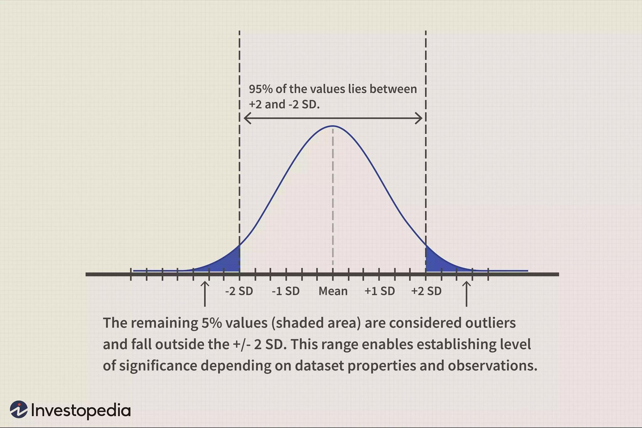

In this case, if the mean of the sample is far higher than 2% (say 3.0%), the null hypothesis is denied. The alternative hypothesis is accepted (mean > 2%) confirming that the daily average inventory return is actually higher than 2%.

However, because the average of the sample is actually not much greater than 2% (and therefore about 2.2%), we CANNOT dismiss the null hypothesis. The challenge is how to decide cases of this kind. A degree of importance needs to be calculated to allow judgment on the null hypothesis in selected samples and tests. The alternate explanation provides for the assessment of the context standard or the definition of "essential importance" in these close-range situations.